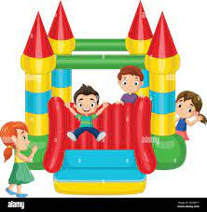
Fall Carnival
Hot Dogs
Popcorn
Snow Cones
Outdoor Family Fun!

October 18
Drawings
Prizes

Games
Food
4-7 p.m.
Rolla Nazarene Church, 1901 E 10th
Proceeds for Rolla Christian Academy
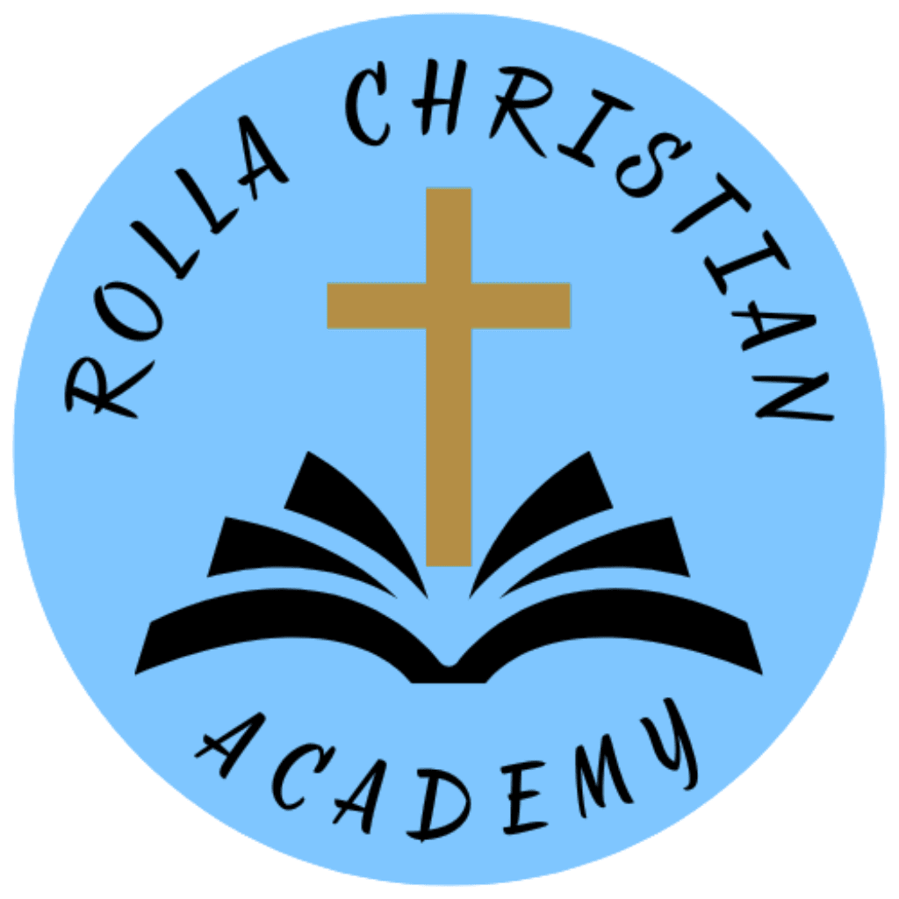
50 cent Tickets
22 Tickets for $10
Good Cause
Christian Education
Need more Information: www.rollachristian.academy or call Beth at 573-368-9702.

